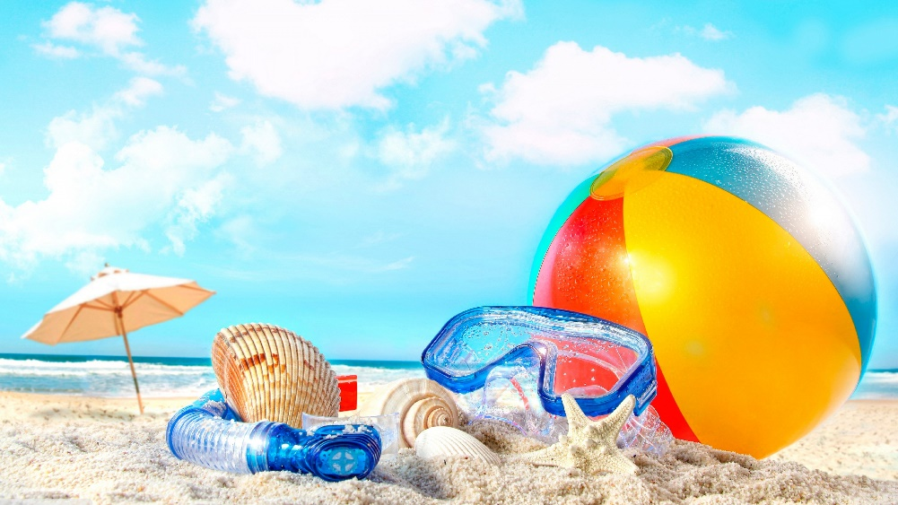
Summer Fun
at LCC

God has given us a great gift on our journey through this life… each other! As a means of growing those relationships and enjoying this life God has given us, we present our Summer Fun Nights.

Every Wednesday evening* from June 15 through July 27, we gather at 5:30pm for a potluck dinner (main dish provided so please bring side/salad/dessert) and inter-generational fun. We’re creating evenings that will include and interest everyone of every generation, so come on out and get involved in the fun!
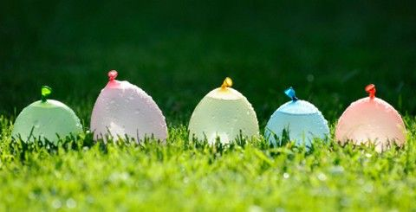
June 15 is Water Night

One of the most common things to show up in scripture is water. From creation to the Red Sea, from baptism in the Jordan to fishing in Galilee, water is a huge part of our world. So, we’re going to play in it! With water balloon tosses and squirt gun races, water relays and soaking sponge dodgeball, everyone can play in the water, whether you want to get wet or stay dry. We’ll have options for both.
*** Wear clothing that can get wet, just in case! ***

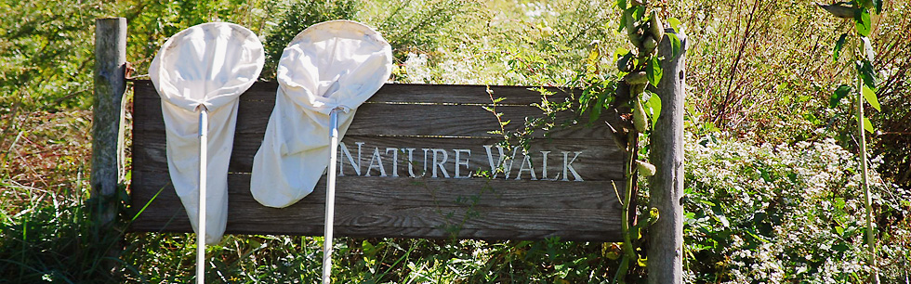June 22 is Nature Night

God has put us in this amazing world and called us to both enjoy it and care for it. In a world of media, we miss the beauty around us too often. Come prepared to take a walk and some pictures in our beautiful surroundings. Bring cameras, butterfly nets, bug vacuums, and walking shoes.
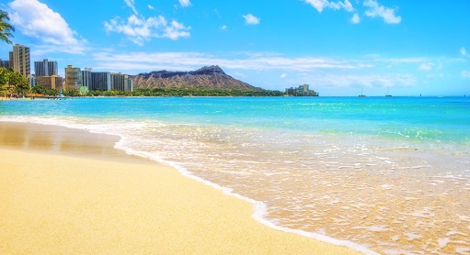
June 29 is
Beach Night

While Willow Point Beach may not look quite like this, it is still fun to get away for a bit on the sandy shores. We gather not at church but at Willow Point Beach (N. Cove Road, Gages Lake) at 5:30pm for an evening of fun and games. Swimming, Frisbee, wiffleball, and more. Tables under the pavilion, blankets in the grass. Bring your lawn chairs and picnic blankets. Dinner is still potluck, it’s just not at LCC!

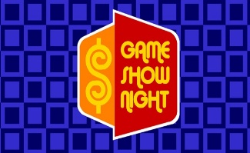
July 6 is
Game Show Night

It is amazing to hear stories of what God’s people know. He has blessed us with wisdom, knowledge, and sometimes a large amount of trivia! What better way to celebrate our beautiful minds what with a Game Show Night? We meet in the Fellowship Hall for our usual potluck dinner and then at 6:15 we’ll divide up teams and play some Game Shows.

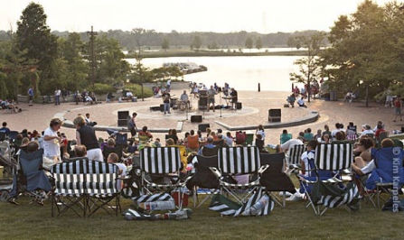
July 12 is
Independence Grove Night

Yes, we realize the 12th is a Tuesday. Yes, we realize that the ‘Special Consensus’ bluegrass concert starts as 7:30pm. And yes, we realize that we can’t cook at Independence Grove. But we can still play together! This night only, our dinner will be Bring Your Own Picnic style (or buy something at the walk-up cafe) and we’ll eat together on the lawn. Bring your lawn games (we’ll have Bocce, Bags, Frisbee, and a Parachute, you bring the rest) and we’ll play until 7pm. At that point, we’ll be done, but if you wish to stay for the 7:30pm concert together, you’re welcomed to! Parking is $6 after 5pm, so come early for free parking or bring your bikes to church by 4:45 and bike over to the park with Pastor Paul!

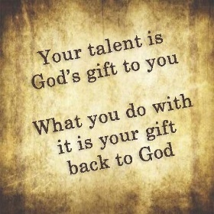
July 20 is
Share-Your-
Talents Night
Part of sharing our lives together is sharing our talents. Do you know how to do something fun that you’d like to teach others for 45 minutes? Would you like to learn a new skill from a friend? We’ve got a whole evening to share our giftings with each other. Let us know asap if you have a skill to share. From cooking to juggling, car repair to guitar chords, sign language to dry walling, we’ve all got skills and we’ve all got needs

July 27 is Olympics Night

Our last night of the summer together will help us prepare for the 2016 Olympic Games. After our dinner on the hill, we’ll divide up into our Olympic teams and go head-to-head in events like the pool noodle javelin, the Frisbee discus, the marshmallow shotput, and more.

