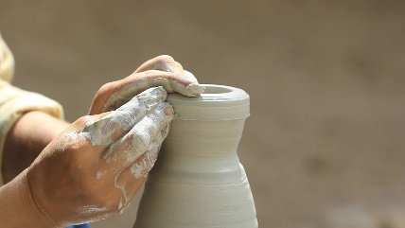
Exploring the SHAPE of my Ministry

What do you feel are your top Spiritual gifts?

What are the things closest to your Heart, your passions?

What are your Abilities (those things you’ve studied or learned)?

How would you best describe your Personality?

What are 2 or 3 major Experiences that have impacted you most?

Given what you’ve discovered about yourself in these five areas…

1. Is your current ministry something you’ve been shaped for by God?

2. What are some other ministries God might have shaped you to do?

3. What will it take for you to join God in the ministry He has been shaping you for throughout your whole life?

