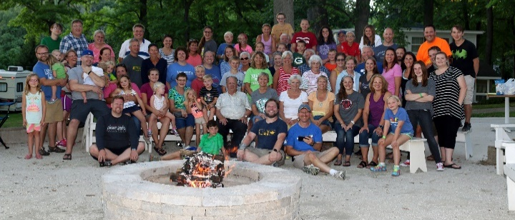
Welcome to Libertyville Covenant Church

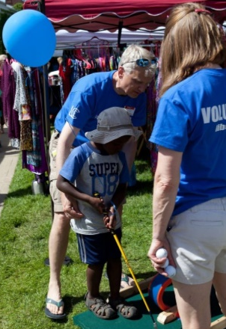
Since 1977 we have been serving God in Lake County. We desire to help people find a personal faith relationship with Jesus Christ and to grow in that faith through inspiring worship, relevant Bible study and hands-on ministry in our community. As a member of the Evangelical Covenant Church we are committed to living the Good News, participating in worldwide mission, and practicing an authentic Christian faith.

Worship – 9:30am (summer only)
Nursery and Children’s Church provided

We would love to meet you. Join us for worship (dress however you’d like) and stay for some snacks and conversation. Or join us for any of our summer activities found on the other side.
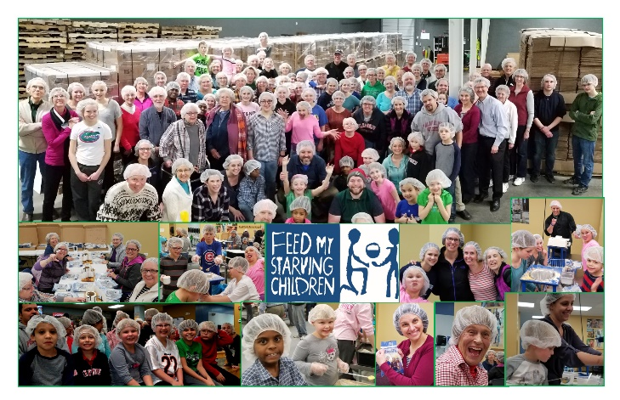
Summer Happenings at LCC

Sundays – Summer Worship (9:30am)

Thursdays – Men’s Ping Pong (7pm)
6/15, 7/6, 7/20, 8/3, 8/17

Thursdays – Youth Group Hang Time (1pm)
6/15, 6/22, 6/29, 7/27, 8/3

Fridays – Preschool Play Date (9-noon)
Family Game Nights (7pm)
(These Friday events are at the Larson’s)

June 2, 3 – Community Wide Rummage Sale

June 7 – Youth Summer Kickoff (2pm)

June 14 – Middle School Movie Night (7pm)

June 16,17 –Libertyville Days Putt-Putt booth

June 21 – All-church Bonfire Night (6pm)

July 8 to 15 – Colombia Mission Trip

July 19,20 – High School Camping Trip

July 26 – All-church Bonfire Night (6pm)

July 28 – Ladies Book Club (7pm @ Vollrath’s)

August 11 to 13 – All Church Retreat

For More Information:
- www.libcov.org
- Call 847-362-3308
- Email us at church@libcov.org

Libertyville Covenant Church
250 S. St. Mary’s Road
Libertyville, IL 60048

