The Drive-Home Newsletter
February 25th, 2018
Greetings wonderful LCC Parents! Sometimes, it is really hard to start a conversation about what happened in Church that day. Questions like “What did you learn today” get met with answers like “About GOD.” Hopefully, this newsletter is helpful in letting you know what the kids are learning about, as well as equipping you with questions to help go deeper in your family’s walk with GOD. GOD Bless!
------------------------------------------------------------------------------------------------------------------------------------------

This week in Sunday School
The Tabernacle

Preschool: Started with different directions that they had to follow just like the Israelites had to follow the directions of GOD. We talked about what tools you need to build something like the tabernacle. GOD told the Israelites to build the tabernacle for GOD. Then, we used things hidden around the room to build a tabernacle. See the picture below to see what we made! What is a tabernacle? It’s a place for GOD. Finally, we built tabernacles out of twizzlers and played with a parachute.
- Who did GOD’s people build the tabernacle for?
- What is a tabernacle?
K-2nd: We discussed the layout of the tabernacle and the different parts, why GOD made it and what the different parts are for. We saw a digital reconstruction of the tabernacle! We talked about how Jesus is the ultimate sacrifice for our lives. We also made buildings out of paper and tape and followed instructions in order to make things with other materials that we were given. Finally, we got to build a tabernacle out of legos! See the picture below to see what we made!
- Look at and color Handout
- What is a tabernacle?
3rd-5th: Did some measuring to see how long the curtains in the tabernacle was and talked about how they created said curtains. We played a matching game with the tabernacle elements, learning what GOD wanted to be put in the Tabernacle. We talked about how the tabernacle was important because it meant that GOD dwells with us (we also talked about what dwell means). Finally, we learned our Bible Memory verse for the unit by putting cards in order to memorize the key verse. See the picture below to see what we accomplished!
- How big was the Tabernacle?
- What is a tabernacle? Why is it important?
This week in Children’s Church
We talked about what it means the Jesus is King in our lives and why we listened to Jesus. We started by noticing the royal purple colors in the narthex and sanctuary. We went downstairs and recapped what we learned last week (repentance is a rope that we GOD gives us to save us, we have to choose to use it though). We played a game of King/Queen for a minute by following the instructions of whoever was wearing the purple robe to learn what it means to have authority. We finished by talking about the fact that we listen to our parents because they know what is best for us and love us. Jesus is the same way, but Jesus also knows everything!
- Why do we listen to Jesus?
- What is the difference between a good king and a bad king?
- Where does authority come from?
- What is authority?
Coming up This Week
Wednesday nights are Kid’s Club! See you all this Wednesday at 5:30pm for dinner, or 6:15pm for the evening program!

Next week is the first week of March which means we will be partaking in communion! Email Bobby if you would like your kids to come up from Children’s church to either observe or participate in Communion. There is a handout on the Children’s Ministry board in the basement hallway with more information about Children and Communion to help facilitate your conversations with your family.
Keep in Mind
Feed My Starving Children Church night will be on March 7th! Sign up here if you haven’t yet! FMSC March 7th sign up

Preschoolers in their tabernacle
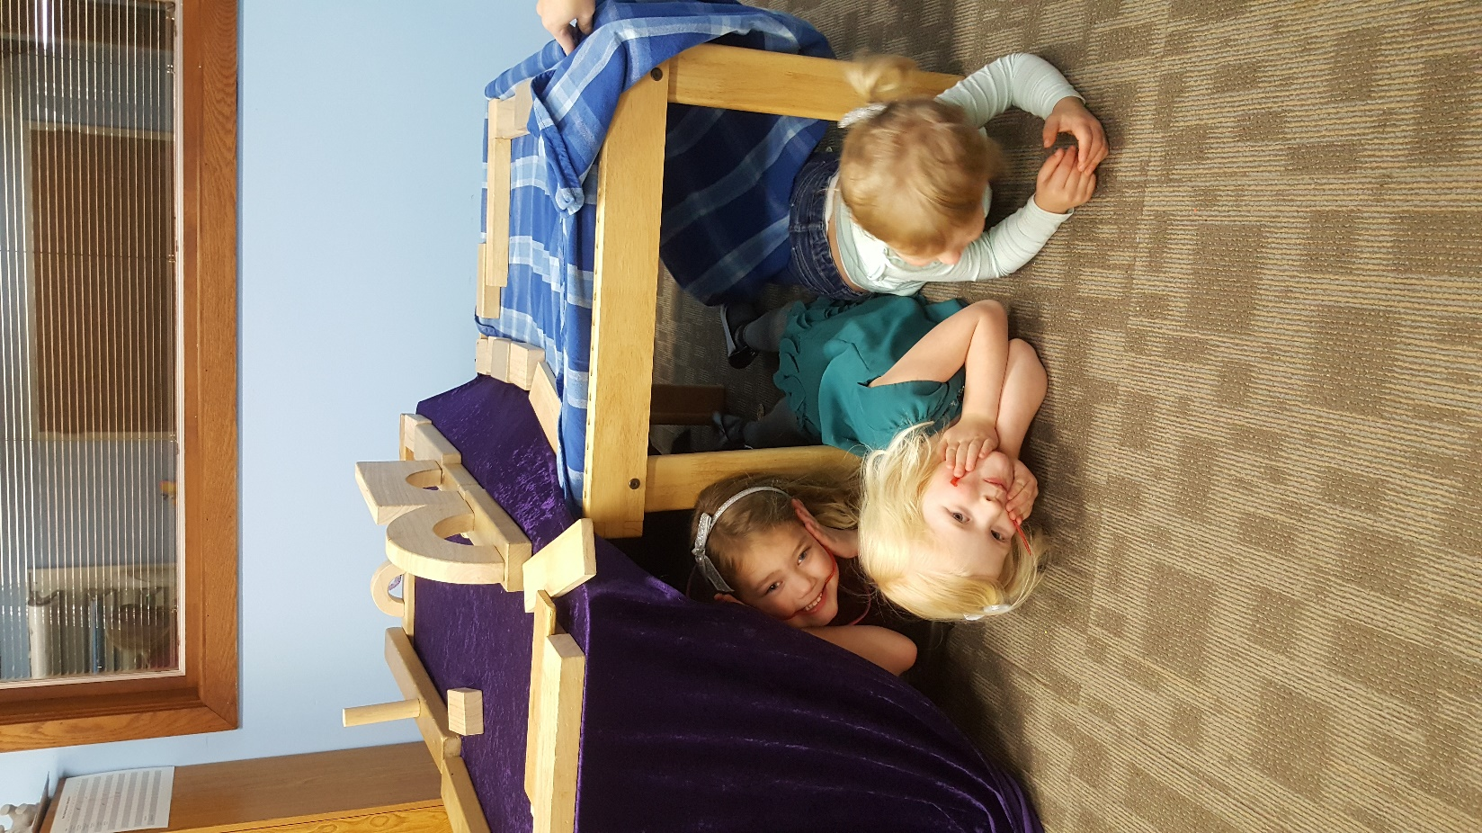

K-2nd Grader’s Tabernacles
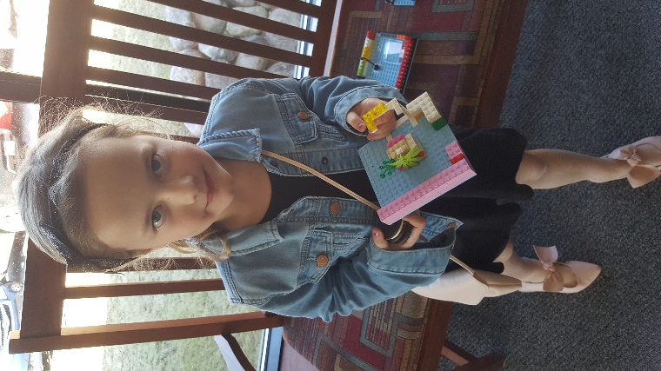
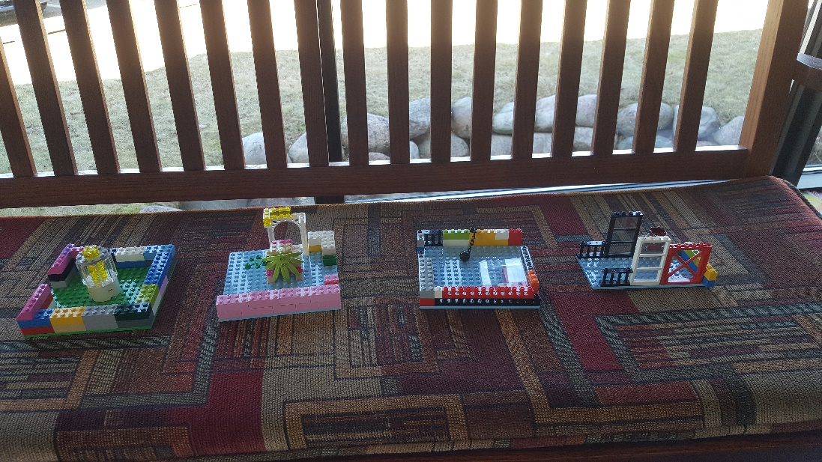

3rd-5th Graders Putting the memory verse in order
