- In the Spirit
A newsletter for the Libertyville Covenant church community about local happenings and Christian issues.

C
d1ddddd

CONTENTS
1 Hope for the Holidays
2 Worship in December
3 Volunteer 2022
Jill’s House 2022
Adult Sunday School
4-6 Youth/Children’s Ministry
7 Summer Camp
8 Adopt-A-Family
Advent/Christmas Events
9 Finance October Summary
10 Finance/Properties Team
11 Dec. Birthdays, Anniversaries and Volunteer Schedule
12 December Calendar

December 2021
Volume 28 Issue 10
Hope for the Holidays
“Even youths grow tired and weary, and young men stumble and fall;
but those who hope in the Lord will renew their strength.” – Isa. 40:30-31

What do you think is the first use of the word Hope in the bible? Or in which book do you think it first shows up? Stop reading for a second and guess. I was shocked to find out that the word Hope doesn’t show up in the NIV until the book of Ruth! And then the first five instances from then until Job are all in a very negative context, either hope unfulfilled or hope in the midst of sin or burden. Then comes Job, which is full of the word hope, but still it is used mostly in negative contexts.
It is the Psalms where we first really see humankind straining toward God in hope. There we are offered hope, called to hope, promised hope and promise to hope in return. Then come the prophets who saw it as one of their main objectives to inspire hope for the coming Messiah.
Today, our situation seems to echo this Old Testament reality. We tend to forget about our hope in the face of our trials, spending our time complaining and grieving our losses rather than sharing the hope we have found. And like Job, we tend to think more about our unfulfilled hopes than the gifts that fill our lives. It is often not until we get to a place of reflection that we remember all God has done and promises to do for us.
This Advent, let’s live truly counter-cultural lives and hope! In our world that believes only what it can see, that spreads complaint and protest, that seeks fulfillment for the moment above all else, the Way of Christ, the Way of Hope, stands out when it is expressed. Like our Advent candles we light each Sunday, we can shine all the brighter because of the darkness of this world. So rather than adding more complaint about COVID and masks, share the hope that God walks this journey with us. Rather than protesting injustice, share the hope that God promises His justice for everyone, often through our advocacy. Rather than adding darkness to this already dark world, let your hope shine, for this is what it means to live as faithful followers of Jesus Christ.
“Now faith is confidence in what we hope for and assurance about what we do not see.” – Heb. 11:1

WORSHIP in December . . .

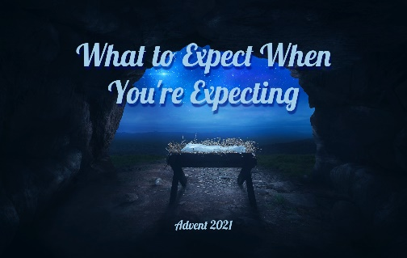
Advent is a season of waiting, expecting, hoping. We wait expectantly for Christmas and all it involves. We remember the long hopeful wait for the Messiah, promised in the Old Testament and fulfilled in Jesus. And we recognize our expectation that Jesus will return. This Advent, we’ll look at all the expectations of Mary, Joseph, the Old Testament prophets, and how Jesus exceeded those expectations. Join us for worship every Sunday at 10:30am or on our YouTube channel. And please join us Christmas Eve for our annual Candlelight service which concludes our Advent series.

Nov. 28 What to Expect When You’re Expecting Isa. 9:1-9
Dec. 5 Expecting the Messiah Luke 1:26-38
Dec. 12 Giving Up Our Expectations Matt. 1:18-25
Dec. 19 What Does God Want for Christmas? Luke 1:46-55
Dec. 24 Christmas Eve: “Exceeds Expectations” Phil. 2:5-11
Dec. 26 A Reason to Rejoice! Can anything good come out of Nazareth Luke 2:22-40

****************************************************************************************

Save the Date!
Feb. 26, 9am – 1pm

The Unhurried Retreat is a mostly self-guided time of quiet prayer and contemplation. With stations and activities all over the church, we have a rare opportunity to “be still and know that I am God.” Come to read, pray, walk, color, create, and maybe even get a massage!
Registration will be available in March.

VOLUNTEER SCHEDULE 2022
The Volunteer Schedule for 2022 is available for sign-ups. There are many different ways that you can help the church: coffee hour, nursery, greeting, and much more. You can click on this link Volunteer 2022 , sign-up on the web site or on the google form that was sent to you, it is that easy. We hope to hear from you soon. January is right around the corner.

Jill’s House 2022 Campouts
We are so grateful for the enthusiasm of our volunteers. Jill’s House is growing and so we have added another campout to our yearly offerings for 2022. Instead of 5 camps, we will be offering 6 happening on the following dates: February 15-17, April 8-10, June 3-5, August 26-28, October 21-23 and December 2-4. You are more than welcome to invite a friend to spend the weekend with you helping these families out! Please contact Kansas Dave if you would like to sign up. Thank you for considering to help these kids and their families!

ADULT SUNDAY SCHOOL
Beginning December 22nd through the 2nd of January 2022 Small Groups will not be meeting due to the Christmas Holiday Season. If you have any questions, please check with your Small Group Leader.

Sensible Ladies Small Group
The next selection for book club is Ordinary Grace by William Krueger
Looking back at a tragic event that occurred during his thirteenth year, Frank Drum explores how a complicated web of secrets, adultery, and betrayal shattered his Methodist family and their small 1961 Minnesota community. Our next meeting will be on Friday, January 14, 2022, 7pm at church.
Youth and Children’s Ministries
SENIOR HIGH MINISTRY

Save the Dates: January 14th to January 17th :
One Life Retreat

One Life strives to call students to out of the ordinary to live “one life” of extra-ordinary devotion to Christ through shared experiences in solid programming, challenging speakers, and meaningful worship. To help students find strength and renewal of faith on a spiritual peak, and develop a rhythm of faith that sustains them when they are not in those high places. In every way One Life retreats strive to encourage students to live further into their calling to whom God has made them to be and go home affecting their communities for the cause of Christ Please register on the web site by clicking One Life Retreat. Registration needs to be in by December 19th.

Come for a weekend of fun and adventure with your high school youth group: complete with worship, broomball tournament, polar bear dip, other fun winter activities, a downhill skiing option, spiritual disciplines, and Christ-centered messages!

Senior High Progressive Dinner Christmas Party!!
December 12th, 12:00-4:00 p.m.
Who: Senior High Students from Libertyville Covenant Church. Please RSVP to paul@libcov.org by December 8th to reserve a spot in the van for some fun.
What/Where: During a progressive dinner, the James’ host appetizers at their home at (825 Tylerton Circle, Grayslake), and then the group transitions to the Andersons house for the main course. Pizza!! The night will finish with dessert, swimming, and arcade games at the Lichter's home (1055 Sunrise Rd in Green Oaks).
When: Sunday December 12th, 2021 from 12:00p.m.-4:00p.m.
Why: Because it's time to throw a Birthday Party for JESUS!!
How: Dress yourself up as if you were a gift you would give to Jesus!! Let's have some fun with this, toss on as much Christmas cheer as you could possibly find, kind of like Buddy the Elf! Bring a silly, funny, and or goofy white elephant gift to share in the gift exchange. Feel free to make them at home or find something cheap online or in the store. Last but not least, bring a swimsuit and towel as we will be swimming over at the Lichters pool for our grand finale.
Drop off and Pick Up: We ask that all students are dropped off at the James’ (825 Tylerton Circle, Grayslake) at 12:00p.m. and you would be able to pick up your student at the Lichter’s home (1055 Sunrise Rd in Green Oaks). at 4:00p.m. Please be sure to have your student bring along a mask for our time together.

Weekly Senior High Happenings: December 5, 12, and 19
- Sunday School, 9:15 am to 10:15 am. Grab a chair from Fellowship Hall and meet us outside.
- Youth Group, Sunday, 5:00 pm. to 7:00 pm. Come prepared appropriately dressed for outside weather.

We hope everyone will enjoy the Christmas vacations and look forward to resuming ministry January 9th.

Senior High Village Retreat

Wow!!! What a great weekend we had at Covenant Harbor! LCC joined together with three other Evangelical Covenant Churches of the Central Conference to create and experience this brand-new fall retreat for high school students. We witnessed sixty people full of amazement engaging in the various team building activities, camp fires, big games, lessons, practices, and many other free time offerings. This retreat went so well that Covenant Harbor has named a hope of offering three retreats of this kind next fall for more and more churches in the Central Conference. We give thanks to God for the great retreat that was shared and what is in store for many retreats to come. Thank you for praying for our retreat as those prayers have been answered in amazing ways.
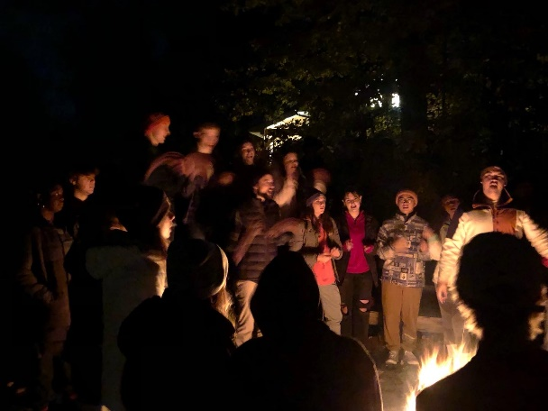
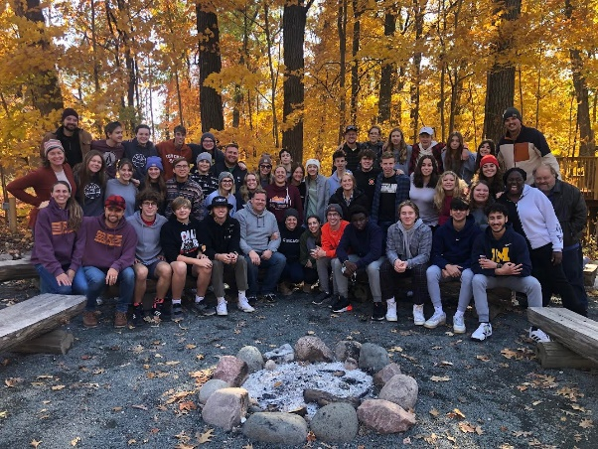
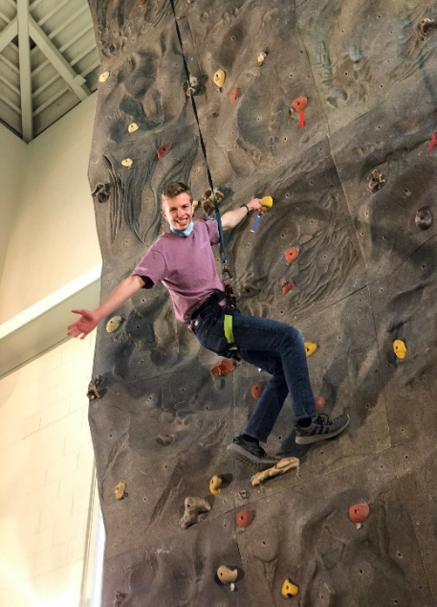

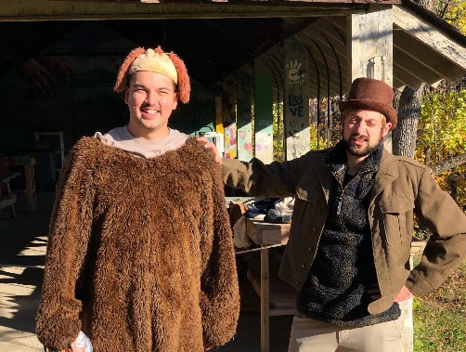
MIDDLE SCHOOL MINISTRY

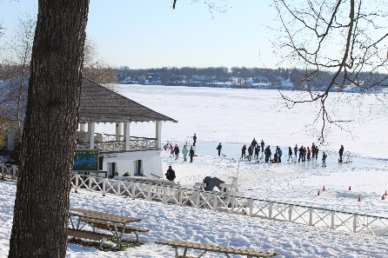
Save the Dates: January 28th to January 30th: Winter Camp Retreat at
Covenant Harbor We are excited to share with you our 2022 theme! Panoramic: 2 Corinthians 4:18, “We set our eyes not on what we see but on what we cannot see. What we see will last only a short time, but what we cannot see will last forever.” Across the world, people get to see and experience awe-inspiring surroundings. Incredible architecture and natural wonders captivate our attention. From where we stand in space and time, we see just a tiny portion of the story, but God has a panoramic view – His wide lens captures the complete picture of all things. Because of this, we don’t focus on the limitations of what we can see, but on the eternal God whose perspective we cannot always see. Join us for Winter Camp 2022 as we travel through Scripture together and explore what it means to set our eyes on God. Please register on the web site by clicking Winter Camp Retreat. RSVPs need to be received before January 7th, 2022.

Middle School Progressive Dinner Christmas Party!!
Who: Middle School Students from Libertyville Covenant Church. Please RSVP to paul@libcov.org by December 15th to reserve a spot in the van for some fun.
What/Where: During a progressive dinner, the Palmberg’s host appetizers at their home at (1522 Lexington in Green Oaks), and then the group transitions to the Andersons house for the main course. Pizza!! The night will finish with dessert, swimming, and arcade games at the Lichter's home (1055 Sunrise Rd in Green Oaks).
When: Saturday December 18th, 2021 from 12:00p.m.-4:00p.m.
Why: Because it's time to throw a Birthday Party for JESUS!!
How: Dress yourself up as if you were a gift you would give to Jesus!! Let's have some fun with this, toss on as much Christmas cheer as you could possibly find, kind of like Buddy the Elf! Bring a silly, funny, and or goofy white elephant gift to share in the gift exchange. Feel free to make them at home or find something cheap online or in the store. Last but not least, bring a swimsuit and towel as we will be swimming over at the Lichter’s pool for our grand finale.
Drop off and Pick Up: We ask that all students are dropped off at the Palmberg’s (1522 Lexington in Green Oaks) at 12:00p.m. and you would be able to pick up your student at the Lichter’s home (1055 Sunrise Rd in Green Oaks). at 4:00p.m. Please be sure to have your student bring along a mask for our time together.

Weekly Middle School Happenings:
- Confirmation/Sunday School, 9:15 am to 10:15 am.
- Wednesdays, 6:00 pm to 7:15 pm
- Classes will be suspended December 22nd for the holidays resuming January 9th.

CHILDREN’S MINISTRIES
Children's Ministry Winter Camp at Covenant Harbor:
January 14-16
Winter Camp for grades 3-6th gives elementary students the opportunity to have a fun and engaging weekend designed for younger students specifically. Just like our Jr. and Sr. High Winter Camps, this weekend includes all the details of activities, food, lodging and the Christian speaker and worship leaders. Our goal is for students and leaders to leave the weekend knowing more about Jesus and feeling more connected to each other in community. Be sure to reach out to Debbie Tometz in the office with any questions. Click here to register.
December 5, 12, 19 plan to experience offerings for children of all ages:
- Children’s Sunday School (9:15 to 10:15)
- Any age thru 4 years old (Drop off at Nursery by the Office on Main floor)
- 5 years of age through 5th grade (Meets downstairs)
- Children’s Church (Will be dismissed midway through the service. Meet teachers at back doors)
  - 5 years of age through 5th grade Paul and Rachel will be leading all of December.
- Nursery (On main level next to Church Office)
  - Offered during Sunday School and the Worship Service

Summer Camp Registration Now Open

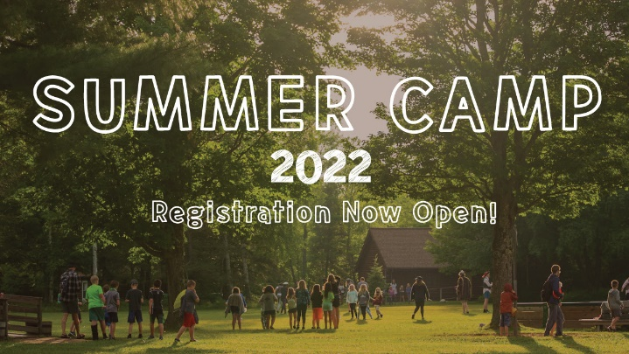
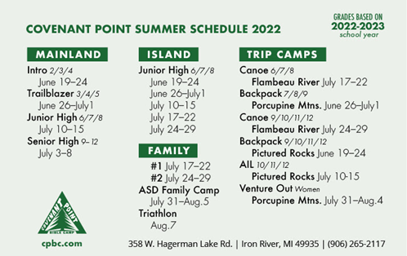
Summer Camp 2022 registration is now open!
We hope you'll join us!
www.cpbc.com/summer

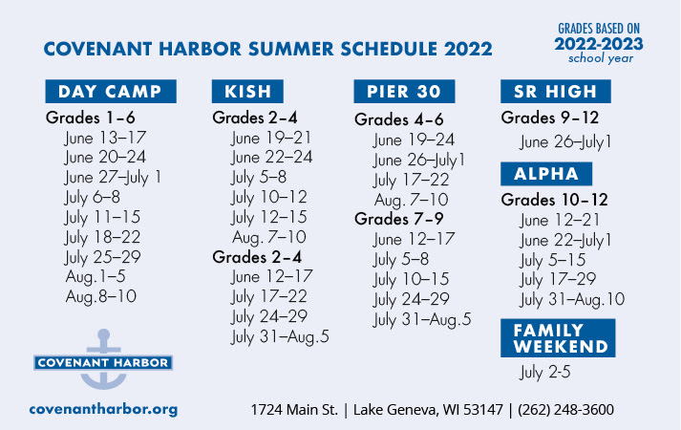

Register for summer camp

ADOPT-A-FAMILY for CHRISTMAS
The wrapped gifts should be returned to church or to Joan Groody’s home prior to December 1st. The child’s name and ID# should be on the package. If you have any questions, or to arrange a drop off time, contact Joan Groody (847-573-8147) or Debbie Tometz (847-362-3308). Thank you for your generosity.

ADVENT

And

CHRISTMAS

EVENTS

Beginning on December 3rd, we hope to see you at some or all of our Advent and Christmas events.

December 3rd: Smorgasbord for our Seniors beginning at 11:30 a.m. The meal can be eaten here or packaged to go.
December 5th: 2nd Sunday of Advent
December 11th: All Church Progressive Dinner, 6:00 p.m. Please sign up here.
December 12th: 3rd Sunday of Advent after our service, we will be taking pictures for the new pictorial directory in the narthex after the service ends. OR, you can also send in your own pictures to office@libcov.org. Deadline to send in pictures is December 15th.
December 12th: Senior High School Progressive Dinner beginning at 12:00 noon
December 18th: Middle School Progressive Dinner beginning at 12:00 noon
December 19th: 4th Sunday of Advent
December 24th: Christmas Eve Service, 4:00 p.m.
December 26th: Pastor Paul Preaching
Calling all musicians! Have you been working on Christmas music on your own or in your lessons? During the Advent and Christmas seasons we are looking for people to share their musical gifts in worship, either live or prerecorded. Please let Kris Nikkel (kjnikkel@aol.com) know if you are interested.

Financial Summary thru
October 2021
EXPENSES VS. BUDGET
Budgeted Expenses YTD | $468,905
Actual Expenses YTD | $437,351
Cost Savings / (Overrun) | $31,554
GIVING VS. BUDGET
Giving YTD (Including spec) | $443,514
Budgeted Giving YTD | $468,905
Giving Surplus / (Deficit) | $(25,391)
INCOME VS. EXPENSES
Income YTD | $443,514
Expenses YTD | $437,351
Operating Surplus / (Deficit) | $6,163
LCC LEADERSHIP
Please pray for the church LEADERSHIP TEAM, COUNCIL & STAFF,
Contact them if you have questions, ideas or would like to get involved in a particular ministry.

STAFF:
Pastor: Steve Larson (815/508-4450)
Associate Pastor to Youth:
Paul Couleur (847/331-3640)
Pastor to Senior Adults:
Bruce Thorson (847/421-2732)
Office Administrator: Debbie Tometz
Choir Director: Kris Nikkel (847/543-8861)
Building Manager: Dan Doherty (847/223-4971)

LEADERSHIP TEAM
Church Council Chair:
Paul Lundstedt (847/612-6237)
Church Council Vice Chair:

Church Council Secretary:
Karen Lundstedt (847/340-5247)
Treasurer:
Dave L. Anderson (847/362-2569
LT Members at Large:
Jill Heath (847/989-7089)
Kirk Johnson (847/573-8010)
Financial Secretary:
Lee & Caren Vollrath (847/549-6906)
Christian Education and Discipleship (CED)

Deacons Team:
Wes Lindahl (847/680-1018)
Evangelism & Service Team:
Trevor James (847/986-6677)
Worship Ministry Team:
Michelle Pas (224/213-5729)
Finance & Properties Team:
Kerry Monson (847/302-4089)
The Leadership Team thanks you all for your continued generous support of the ministries of LCC. We thank God for you and His good work that can be accomplished through your faithfulness. If you have any questions or concerns regarding our finances, please contact our Treasurer, “Kansas” Dave Anderson at 847-910-1696 or danderson@proactiongroup.com.
Thanks, Dave for your work on our behalf!
LINK to online giving
Checks mailed to the church will also be received and processed on a regular basis. If you have questions, contact Caren & Lee Vollrath at carenvollrath@gmail.com or 847/549-6906
Finance and Properties
2021 Year End Giving Opportunities
Recognizing that December typically is the highest giving month of the year, we wanted to provide an update on our finances thru October and share several specific gifting opportunities for year end.
Thru Oct, 2021 we have an operating surplus of $6,000. This is due to the wonderful generosity of our church family and lower than expected expenses. We pray that our giving will continue strongly in December to allow us to finish with a positive operating budget for the year.
Additional areas of specific need include:
Benevolent Fund: $8,000 to $10,000 additional needed (current balance totals $5,500)
Camping Fund: $6,000 additional needed (current funds total $4,000)
Capital Improvement Fund: $30,000 needed for exterior siding replacement (2022 Project)

If you would like your giving to support any of these needs, please include a note with your check or online donation. We thank you for your faithful stewardship and commitment to the continued ministry of Libertyville Covenant Church!
A couple of main projects were completed in November: the new flat roof and siding on the upper half of the church building.
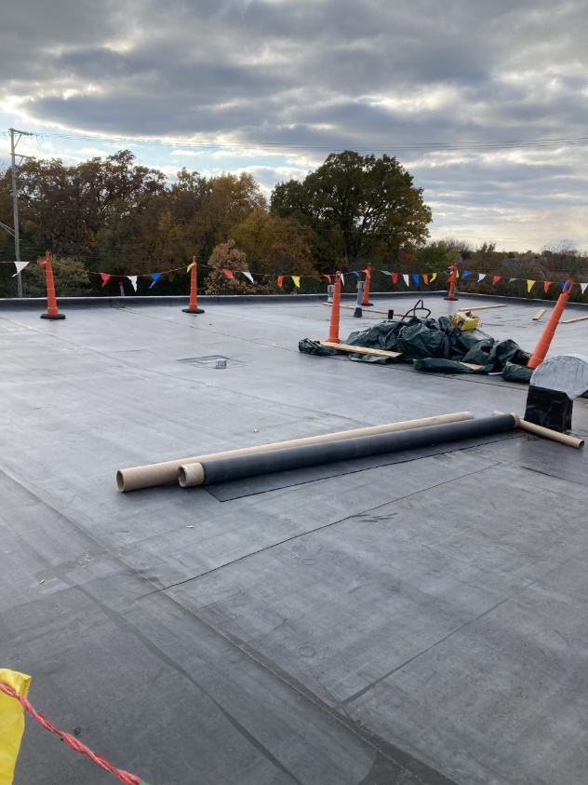
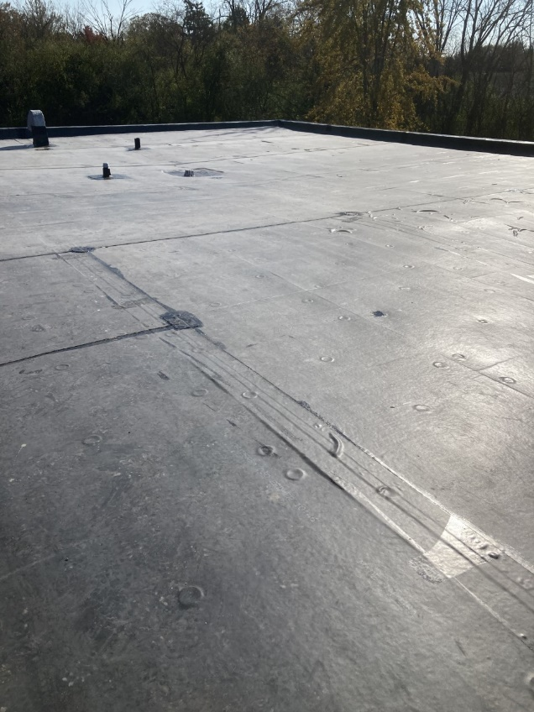
December Volunteer Schedule
December Birthdays |  | December Anniversaries
2 Maggie Johnson | 18 Alex Couleur, Kajsa Hawkinson, Chris Johnson | 3 David and Karen Hinz (1995)
6 Anja Beckstrom | 20 Carson Hawkinson  Earleen Johnson | 11 Nathan and Melissa Schau (2004)
8 Griffin Johnson | 22 Lee Vollrath | 28 Karl and Sue Peterson (1985)
9 Wylie Douglass | 24 Amy Keller | 31 Ben and Sarah Palmberg (2000)
12 Joshua Larson | 27 Leija Dalton
15 Mark Cederberg  Carl Zienty | 28 Carol Dieball, Vern Johnson
16 Alec Tranel | 30 Ken Werner
 | 31 Gracie Greenfield, Jim Pas

Date | Coffee Hour | Lay Reader | Greeters | Ushers
12/5/2021 | Dave and Marie Oppedahl | Angela Kocinski and Kelly | Paul and Kristin Hawkinson | Bob Hartnett and Al Nielson
12/12/2021 | Ben and Sarah Palmberg | Paul Nauman | Dave and Karen Hinz | Bob Hartnett and Al Nielson
12/19/2021 | Staff | Jackie Splinter | Lisa Kindstrom/Laura Nordgren | Bob Hartnett and Al Nielson
12/26/2021 | Niki Papak | Vick Herrick | Paul and Karin Lundstedt | Bob Hartnett and Al Nielson
Date | Sunday School | Children’s Church | Sunday School Nursery | Worship Nursery
12/5/2021 |  | Rachel Couleur |  | Kat Tranel
12/12/2021 |  | Rachel Couleur |  | Angela Kocinski
12/19/2021 |  | Rachel Couleur
12/26/2021 |  | Rachel Couleur |  | Kiristen P and Karin H
December 2021

Recurring Weekly Events
Sunday: 9:15 Sunday School for all Ages
10:30 Worship
12:00 Choir
5:00 p.m. High School Youth Group

Monday: 7:00 p.m. Larson’s SG
7:00 p.m. NA

Tuesday: 1st Tuesday: 7:00 p.m. Youth Life Capeneum
2nd Tuesday: 7:00 p.m. Worship Ministry Team
3rd Tuesday: 5:30 p.m. Leadership Team
4th Tuesday: 7:00 p.m. Deacons

Wednesday: 9:30 Nauman SG
6:00 p.m. Middle School Youth Group
6:00 p.m. Prayer Meeting

Thursday: 9:15 Women’s SG
6:30 p.m. Racial Righteousness SG
7:00 p.m. Men’s Ping Pong

Friday: 7:00 Men’s SG

Saturday: 1st Saturday Furniture Ministry
2nd/4th Saturday 9:30 Kindstrom SG
Libertyville Covenant Church
250 S. St. Mary’s Road, Libertyville, Illinois 60048
(Corner of Route 176 and St. Mary’s Road)
Pastor: Steve Larson
Church phone: 847/362-3308 Fax: 847/362-3310
www.libcov.org

