December
2021
Sunday | Monday | Tuesday | Wednesday | Thursday | Friday | Saturday
 |  |  | 1 | 2 | 3 | 4
 |  |  | 6:00 pm Middle School Youth Group
5 | 6 | 7 | 8 | 9 | 10 | 11
9 am Sunday School, Confirmation Class  10:30 Worship  5:00 pm Youth Group |  |  | 6:00 pm Middle School Youth Group
12 | 13 | 14 | 15 | 16 | 17 | 18
9 am Sunday School  10:30 Worship  12:00 Sr. High Progressive Dinner |  |  | 6:00 pm Middle School Youth Group |  |  | 12:00 noon Middle School Progressive Dinner  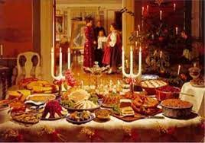
19 | 20 | 21 | 22 | 23 | 24 | 25
9 am Sunday School  10:30 Worship  5:00 pm Youth Group |  |  |  |  |  | Christmas Day
26 | 27 | 28 | 29 | 30 | 31
10:30 Worship

